**water filtration**

**Aswda Hamza**

**Salahaddin University - College Of Engineering**

**Electrical Department**

**Outline:**

* **Introduction**
* **System overview**
* **Ladder logic and system implementation**
* **Conclusion**

**Introduction:**

Water filtration is an essential process to ensure clean and safe water for various applications. In this project, an automated water filtration system is designed using a Delta PLC, integrating sensors and motors to streamline the filtration process across three interconnected tanks. The automation aims to improve efficiency, reduce manual intervention, and ensure consistent water quality.

The system operates as follows:

* Water is first collected in **Tank 1**, where the high-level sensor detects when the tank is full. This triggers the transfer of water to **Tank 2**.
* In **Tank 2**, when the high-level sensor is activated, blowers start to operate, ensuring proper aeration. Subsequently, a motor initiates the transfer of water to **Tank 3**.
* In **Tank 3**, the high-level sensor activates the UV motor to begin the water purification process. The water is then mixed using a motor to ensure thorough treatment. The UV motor and mixer operate alternately to finalize the filtration process.
* Once the water is purified, it becomes ready for use.

**System overview:**

**Process Description:**

The water filtration system is fully automated and operates through three interconnected tanks, each equipped with sensors and motors to ensure continuous and efficient water processing:

**Tank 1**:

* + Water is collected in Tank 1.
  + **Low-level** and **high-level sensors** monitor the water level:
    - The low-level sensor prevents the system from operating when Tank 1 is empty.
    - The high-level sensor signals the transfer of water to Tank 2.
  + Two motors are used to transfer water from Tank 1 to Tank 2, working alternately for continuous operation.

**Tank 2**:

* + Water enters Tank 2, where **low-level** and **high-level sensors** ensure proper water management:
    - The low-level sensor halts operations if water drops below a critical level.
    - The high-level sensor triggers the next stage.
  + **Two blowers** operate in two phases for aeration:
    - The first blower works for 2 hours.
    - The second blower operates for another 2 hours.
  + After aeration, two motors transfer water to Tank 3, alternating to ensure smooth operation.

**Tank 3**:

* + Tank 3 performs the final purification process, monitored by **low-level** and **high-level sensors**:
    - The low-level sensor halts operations when water is insufficient.
    - The high-level sensor initiates the purification cycle.
  + The purification cycle consists of **four steps**:

1. The UV motor operates to sterilize the water.
2. The mixer motor starts to thoroughly mix the water.
3. The UV motor operates again for additional sterilization.
4. The mixer motor works a second time for final processing.
   * Once the purification cycle is complete, two transfer motors work alternately to discharge the clean water for use.

**Hardware Used:**

* **Delta PLC**: Controls the automation process.
* **Sensors**:
  + High-level and low-level sensors in each tank to monitor water levels.
* **Blowers**: Two blowers in Tank 2 for aeration.
* **Motors**:
  + Transfer motors between tanks and for discharging water.
  + UV motor for sterilization in Tank 3.
  + Mixer motor for thorough mixing in Tank 3.

**Software Used:**

* The Delta PLC is programmed using **ISPSoft** or a similar ladder logic programming tool to automate the sequence of operations based on sensor feedback.

**Ladder logic and system implementation:**

Rather than using a timer, we used a counter to function as a timer. In Delta PLCs, the timer's K10 equals 1 second so instead, we utilize the M1013 flag, which generates a pulse every 0.5 seconds, allowing for more flexibility and precision.

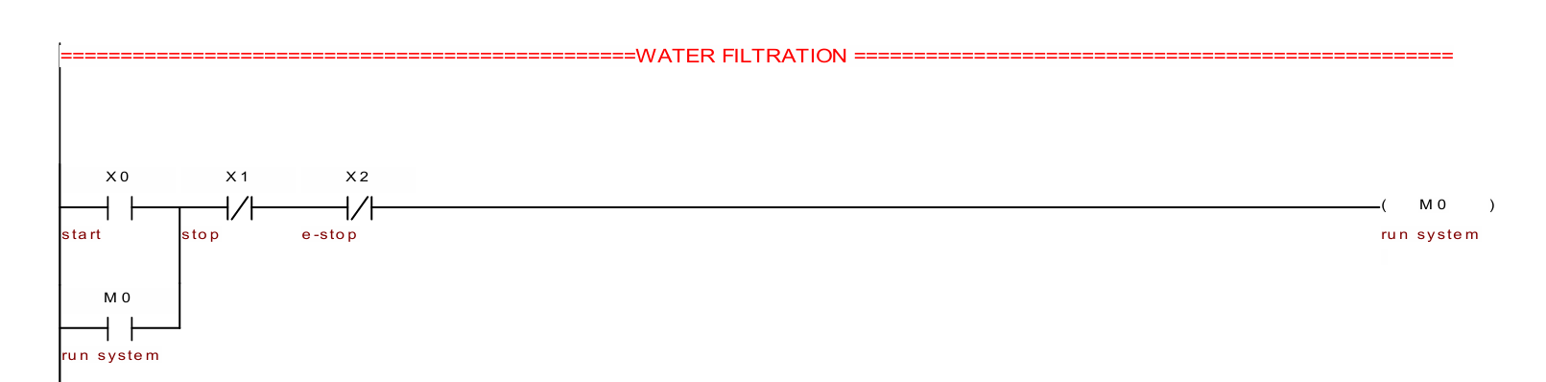

In this part of the ladder, we connected the start button, stop button, and emergency button, all integrated with a relay named 'Run System.' When the emergency button is pressed, it immediately shuts down all operations, ensuring safety and control.

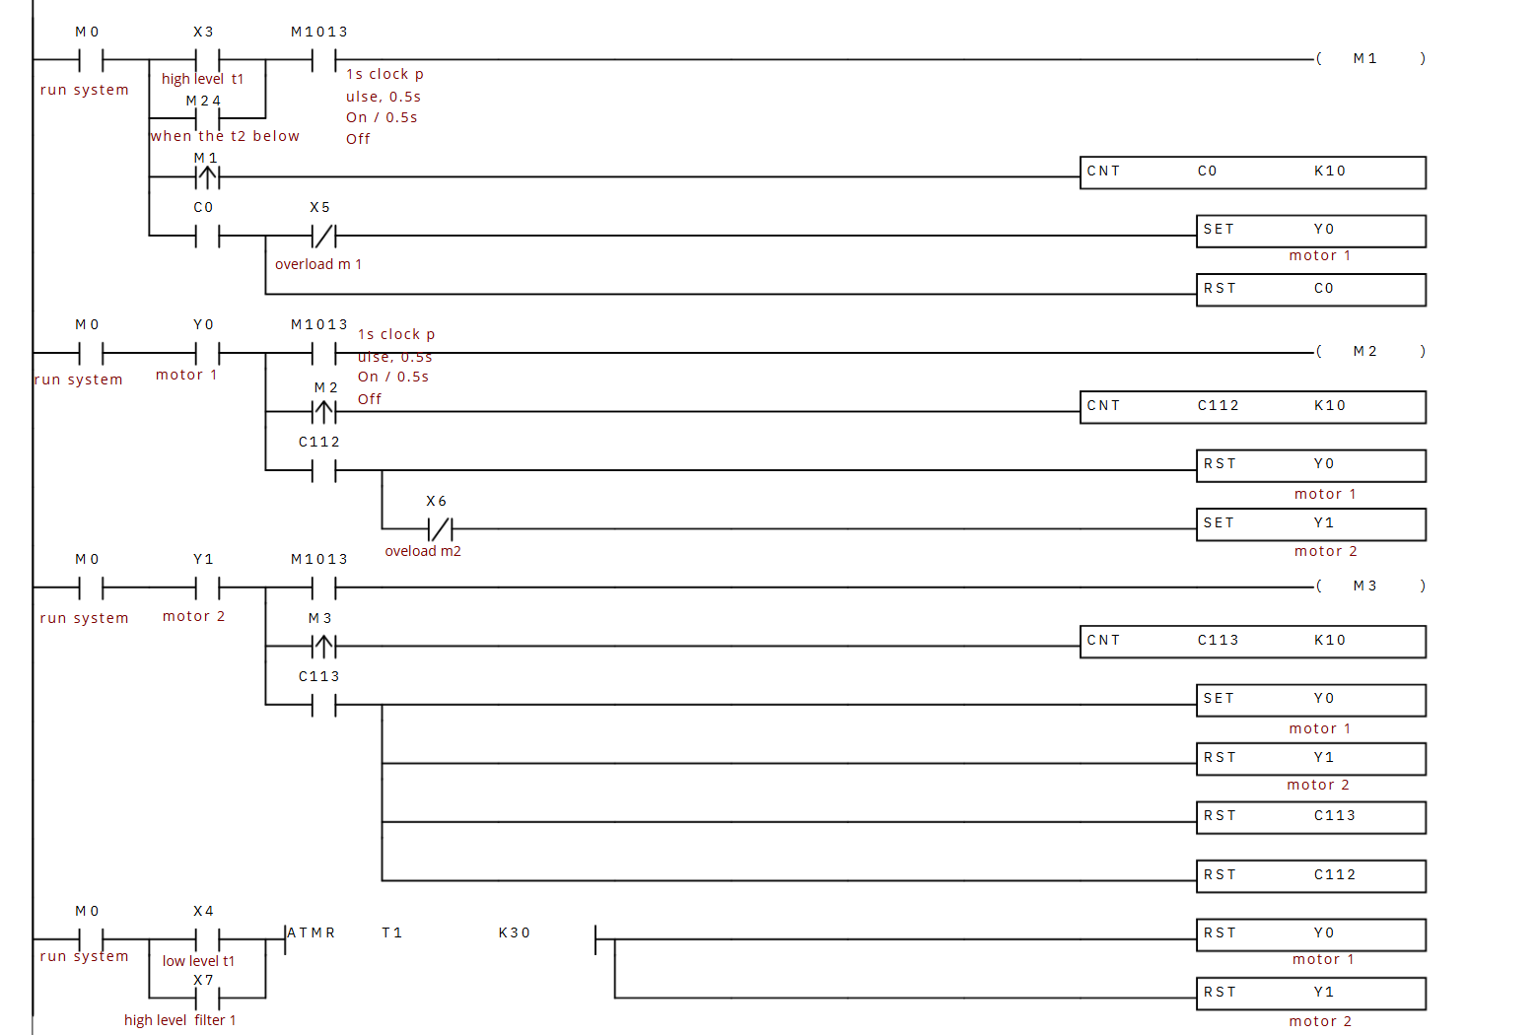

**Process Description:**

1. **Tank 1 Motor Activation**:
   * The **first motor** of Tank 1 is activated when:
     + The **high-level sensor** of Tank 1 is triggered, or
     + The **low-level sensor** of Tank 2 is triggered.
2. **Motor Alternation for Tank 1**:
   * The two motors of Tank 1 alternate operation to evenly distribute workload.
     + The **first motor** runs for **2 hours**, then rests.
     + The **second motor** takes over and runs for **2 hours**.
   * This alternating process continues until:
     + The **low-level sensor** of Tank 1 is activated, or
     + The **high-level sensor** of Tank 2 is triggered.
3. **Timer Adjustment for Simulation**:
   * In the simulation, the **real-time duration of 2 hours** is shortened to a timer value of **K10** for demonstration purposes.
   * In real-world implementation, this timer will correspond to a duration of **2 hours per motor**.

**Ladder logic implementation:**

1. **Sensors and Inputs**:
   * **High-Level Sensor (Tank 1)**: Detects when Tank 1 is near capacity.
   * **Low-Level Sensor (Tank 2)**: Detects when Tank 2 requires more water.
2. **Outputs**:
   * **Motor 1 (Tank 1)**: Activated for 2 hours, then rests.
   * **Motor 2 (Tank 1)**: Takes over after Motor 1, runs for 2 hours.
3. **Timers**:
   * **Timer (K10)**: Used in simulation to represent the 2-hour duration for motor alternation.
4. **Logic Flow**:
   * When conditions from Tank 1's high-level sensor or Tank 2's low-level sensor are met, the **motor alternation logic** starts.

**Timer-based alternation** ensures balanced operation between the two motors.

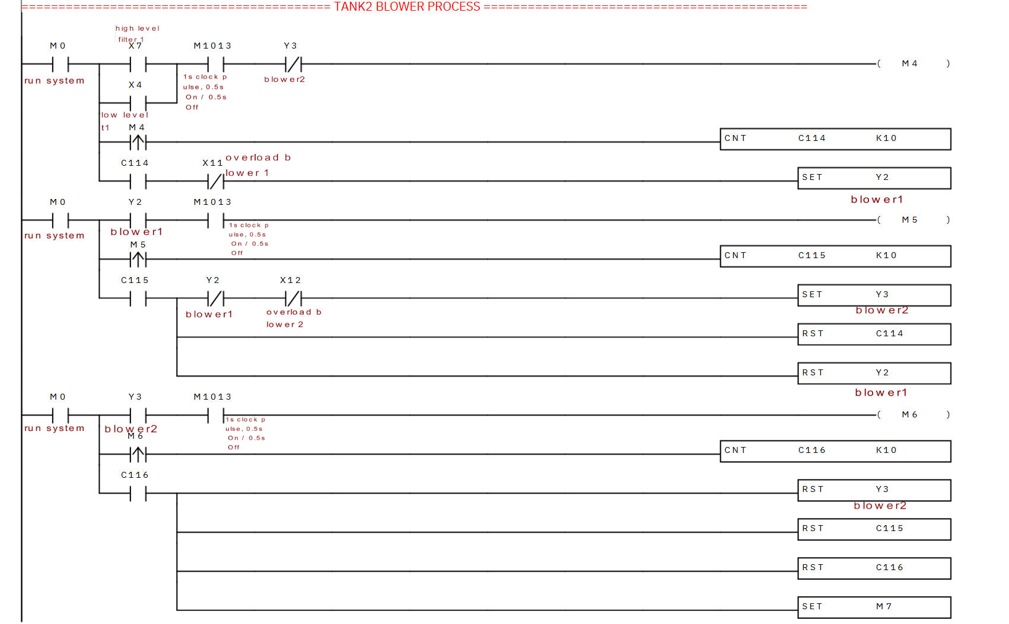

#### **Process Description:**

1. **Blower Operation in Tank 2**:
   * The blowers in Tank 2 operate when:
     + The **high-level sensor** of Tank 2 is triggered, or
     + The **low-level sensor** of Tank 1 is activated.
2. **Blower Alternation**:
   * The two blowers in Tank 2 alternate to balance workload and prevent overheating:
     + The **first blower** runs for **2 hours**, then rests.
     + The **second blower** takes over and runs for the next **2 hours**.
   * This alternation continues until:
     + Both blowers are shut down automatically when conditions no longer require their operation.
3. **Motor Activation in Tank 2**:
   * After the alternating blower operation is complete, the **first motor of Tank 2** is activated to continue the filtration process.
4. **Timer Adjustment for Simulation**:
   * In the simulation environment, the **2-hour duration** is shortened to a timer value of **K10** to demonstrate functionality.
   * For real-world operation, the system will be configured for **2-hour intervals**.

#### **Ladder Logic Implementation:**

1. **Inputs and Conditions**:
   * **High-Level Sensor (Tank 2)**: Detects when Tank 2 reaches capacity.
   * **Low-Level Sensor (Tank 1)**: Signals when Tank 1 requires water transfer.
2. **Outputs**:
   * **Blower 1 (Tank 2)**: Operates for 2 hours and then rests.
   * **Blower 2 (Tank 2)**: Takes over from Blower 1 and operates for the next 2 hours.
   * **Motor 1 (Tank 2)**: Activates after blower alternation is complete.
3. **Timers**:
   * **Timer (K10)**: Used in simulation to represent the real-time 2-hour duration for blower operation.
4. **Logic Flow**:
   * When triggered by Tank 2’s high level or Tank 1’s low level, the **blower alternation process** starts.
   * **Blowers alternate operation** every 2 hours using timer-based logic, ensuring even wear.
   * After blower alternation, **Motor 1 in Tank 2** is activated to continue the process.
   * Once conditions normalize, the system shuts down the blowers and motors automatically.

#### **Process Description:**

1. **Blower Operation in Tank 2**:
   * The **blowers** in Tank 2 operate alternately for **2-hour intervals**, as described previously.
   * After the **second blower** completes its 2-hour operation, there is a **3-second delay** before the motor operations begin.
2. **Motor Alternation in Tank 2**:
   * Following the blower operation, the **first motor** of Tank 2 starts and runs for **2 hours**.
   * After 2 hours, the **first motor** shuts down, and the **second motor** of Tank 2 takes over, running for the next **2 hours**.
   * This alternation between Motor 1 and Motor 2 continues until:
     + The **low-level sensor** of Tank 2 is activated, or
     + The **high-level sensor** of Tank 3 is triggered.
3. **Shutdown Condition**:
   * When the **low-level sensor of Tank 2** or **high-level sensor of Tank 3** is activated, the motors are automatically reset, and the system halts operation.
4. **Timer Adjustment for Simulation**:
   * In the simulation, the **2-hour motor duration** and **3-second delay** are represented using shortened timers (**K10**) for demonstration purposes.
   * In real-world implementation, the timers will correspond to actual durations.

**Ladder Logic Implementation:**

1. **Inputs and Conditions**:
   * **Low-Level Sensor (Tank 2)**: Detects when Tank 2 is near empty.
   * **High-Level Sensor (Tank 3)**: Detects when Tank 3 reaches capacity.
2. **Outputs**:
   * **Motor 1 (Tank 2)**: Operates for 2 hours, then rests.
   * **Motor 2 (Tank 2)**: Operates after Motor 1 for 2 hours.
3. **Timers**:
   * **Timer 1 (K10)**: Represents the 2-hour motor operation in the simulation.
   * **Timer 2 (3 seconds)**: Adds a delay after the second blower before Motor 1 starts.
4. **Logic Flow**:
   * After the **second blower** finishes its operation, a **3-second delay** (Timer 2) is introduced.
   * **Motor 1** is activated and runs for 2 hours.
   * After 2 hours, **Motor 1** is reset, and **Motor 2** is activated for the next 2 hours.
   * This alternation continues until either:
     + The **low-level sensor of Tank 2** triggers, or
     + The **high-level sensor of Tank 3** triggers.
   * Upon meeting these conditions, both motors are reset, halting the system.

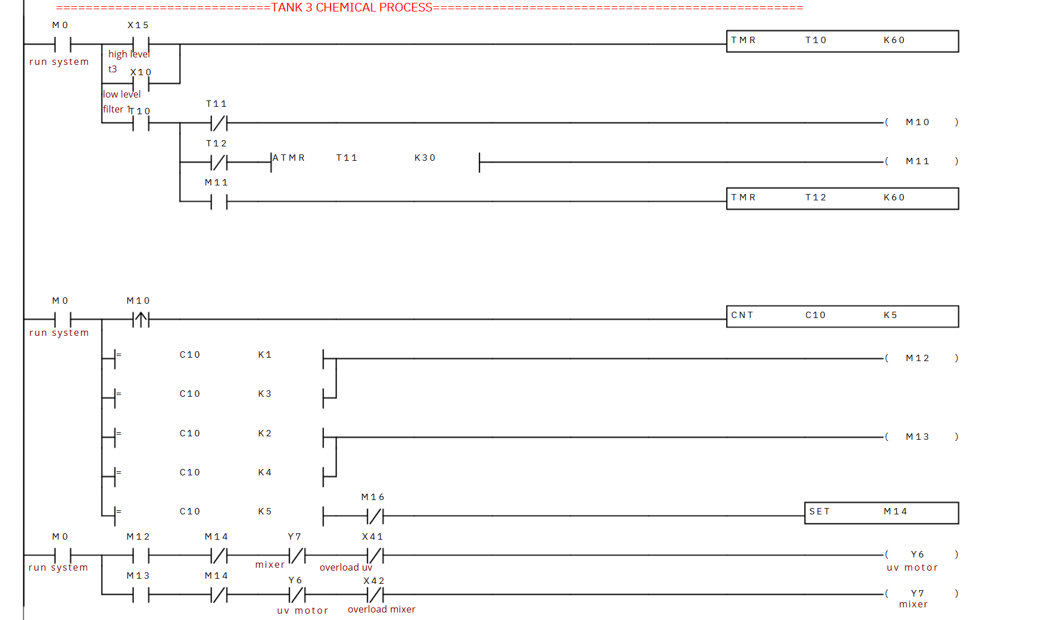

#### **Process Description:**

1. **Trigger Conditions**:
   * The UV motor starts **only if**:
     + **High level** is reached in Tank 3 **OR**
     + **Low level** is detected in Tank 2.
2. **UV Motor Operation**:
   * When triggered, the UV motor operates for **30 minutes**.
3. **Mixer Motor Operation**:
   * After the UV motor stops, the **Mixer motor** operates for **1 hour**.
4. **Sequential Cycle**:
   * Following the Mixer motor operation:
     + The UV motor starts again for **30 minutes**.
     + The UV motor is reset automatically after 30 minutes.
     + The Mixer motor runs for another **1 hour**.
5. **Shutdown**:
   * After the second cycle, both the UV motor and the Mixer motor are shut down.
6. **Tank 3 Motor Operation**:
   * Finally, the **Tank 3 motor** is activated to conclude the process.

### **Ladder Logic Implementation:**

1. **High-Level/Low-Level Trigger**:
   * The UV motor starts when the high level of Tank 3 is reached or the low level of Tank 2 is detected.
2. **UV Motor Timer**:
   * A timer is initiated when the UV motor starts, keeping it active for 30 minutes.
3. **Mixer Motor Activation**:
   * After the UV motor timer completes, the Mixer motor is triggered and remains ON for 1 hour.
4. **Second UV-Motor Cycle**:
   * Upon completion of the Mixer motor's operation, the UV motor restarts for another 30 minutes, controlled by the timer.
5. **Reset and Second Mixer Motor Cycle**:
   * The UV motor is reset after its second 30-minute operation. The Mixer motor activates again for another hour.
6. **Shutdown**:
   * Both the UV motor and the Mixer motor shut down after completing the second cycle.
7. **Tank 3 Motor Activation**:
   * The process ends with the Tank 3 motor being triggered to continue the filtration process.

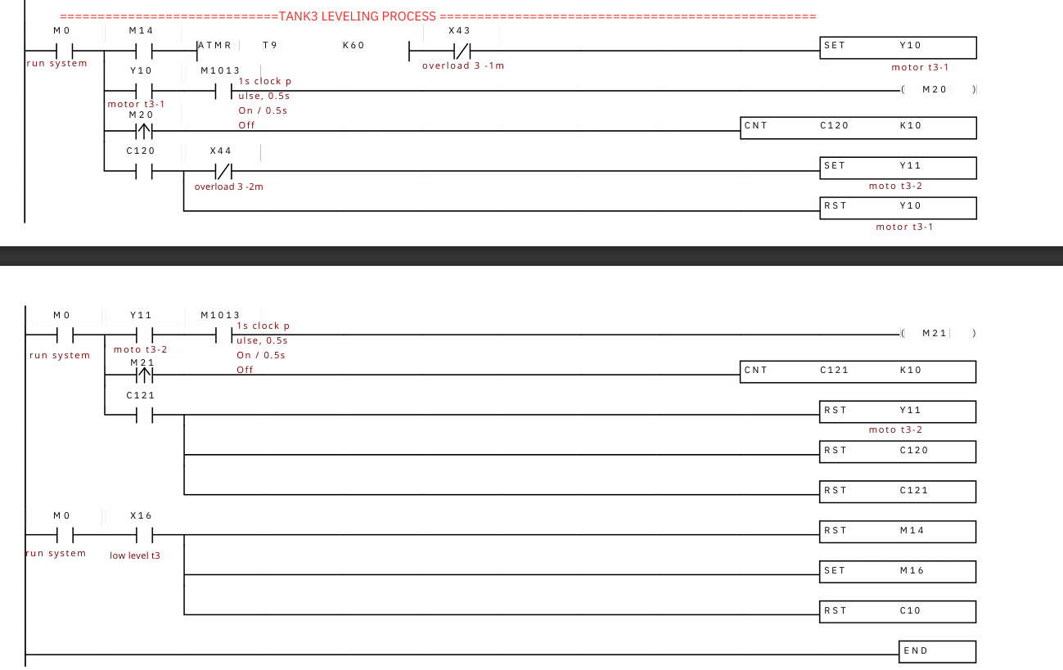

#### **Process Description:**

1. **Initial Condition**:
   * The process starts when the **Mixer motor stops**.
2. **First Motor Operation**:
   * The **First motor** of Tank 3 runs for **2 hours**.
3. **Second Motor Activation**:
   * After the **First motor** completes its 2-hour operation:
     + The **Second motor** of Tank 3 activates.
     + The **First motor** resets.
4. **Cyclic Motor Switching**:
   * The **Second motor** runs for **2 hours**, after which:
     + It resets.
     + The **First motor** is reactivated for another 2 hours.
   * This cycle alternates continuously.
5. **Low-Level Trigger in Tank 3**:
   * When a **Low level** is detected in Tank 3:
     + Both the **First motor** and **Second motor** are reset.
     + The process halts until the low-level condition is resolved.

#### **Ladder Logic Implementation:**

1. **Mixer Motor Stops**:
   * When the **Mixer motor stops**, the **First motor** of Tank 3 starts.
2. **First Motor Timer**:
   * A **2-hour timer** (Timer A) begins as the **First motor** starts.
   * After 2 hours:
     + The **First motor** resets.
     + The **Second motor** of Tank 3 starts.
3. **Second Motor Timer**:
   * A **2-hour timer** (Timer B) begins as the **Second motor** starts.
   * After 2 hours:
     + The **Second motor** resets.
     + The **First motor** starts again.
4. **Cyclic Operation**:
   * This alternating cycle of 2-hour operations between the **First motor** and **Second motor** continues.
5. **Low-Level Reset**:
   * When the **Low-Level Sensor** in Tank 3 is activated:
     + Both the **First motor** and **Second motor** reset.
     + The system halts until the low-level condition is resolved.

#### **PLC Details:**

* **PLC Software**: Delta WPLSoft 2.52
* **Inputs**:
  + Mixer Motor Status: Stop
  + Low-Level Sensor in Tank 3
* **Outputs**:
  + First Motor of Tank 3
  + Second Motor of Tank 3
* **Timers**:
  + Timer A: 2-hour operation for the First motor.
  + Timer B: 2-hour operation for the Second motor.

**Conclusion:**

This project successfully automated a multi-stage water filtration system using a Delta PLC. The system efficiently manages the filtration process across three interconnected tanks, utilizing high-level and low-level sensors to control water levels and motors to transfer water seamlessly. In Tank 2, the integration of two blowers ensures proper aeration, while Tank 3 leverages UV and mixer motors for thorough purification.

The use of Delta PLC provided precise control and coordination between the various components, ensuring continuous operation without manual intervention. The alternating operation of motors and blowers optimized energy usage while maintaining system reliability.

Overall, the system achieved its objective of delivering clean and safe water through an efficient, automated process. Future improvements could include incorporating remote monitoring or data logging to further enhance the system's capabilities and usability.